**How to install an apache tomcat and set up their necessaries:-**

First we create an instance and login successfully.

After that we enter “download tomcat” in google browser next click on your required link.

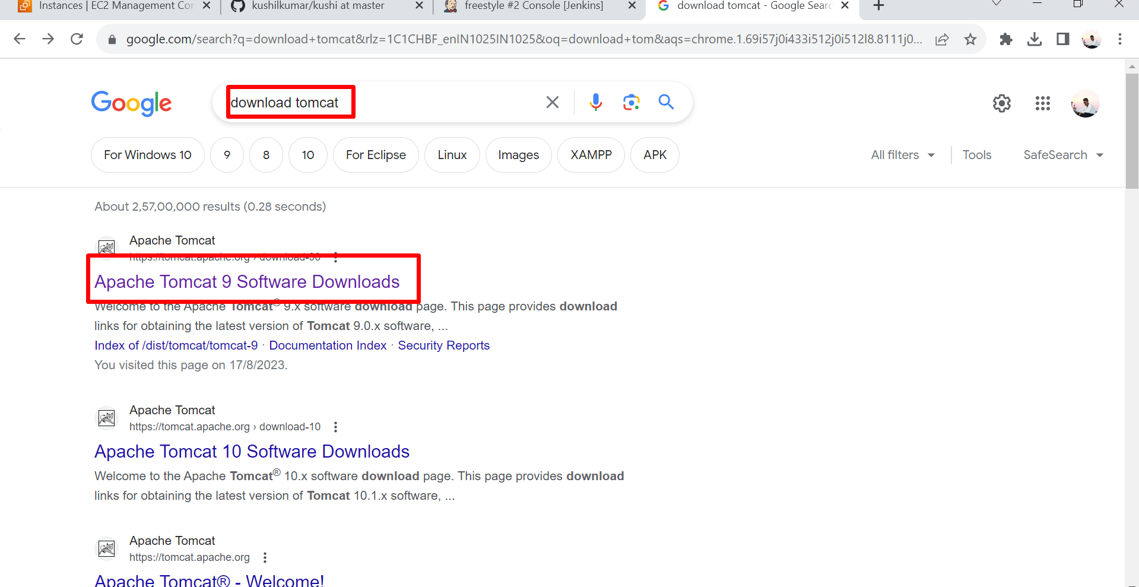

After that we right click on **tar.gz** and copy **link address.**

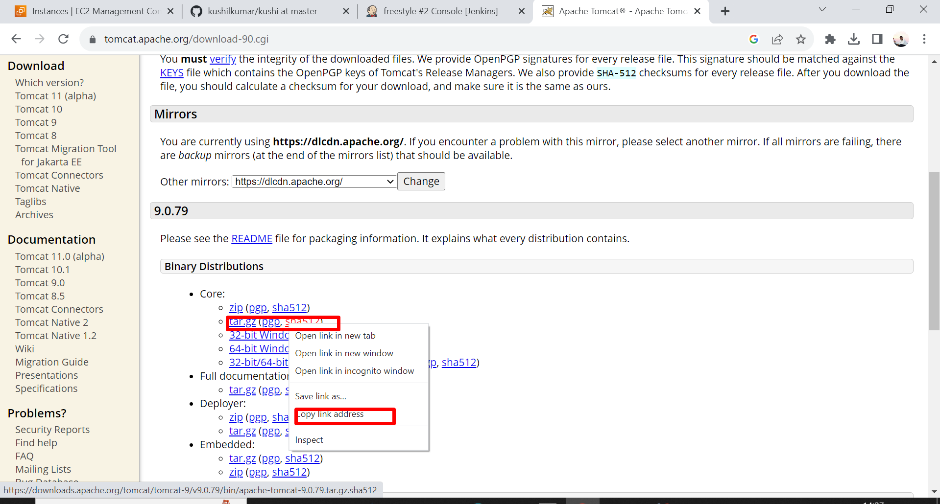

After that go to Ubuntu server change directory to opt path

Using **cd opt/** and after that we paste the copy link in this like

Command: - **sudo wget https://dlcdn.apache.org/tomcat/tomcat-9/v9.0.79/bin/apache-tomcat-9.0.79.tar.gz**

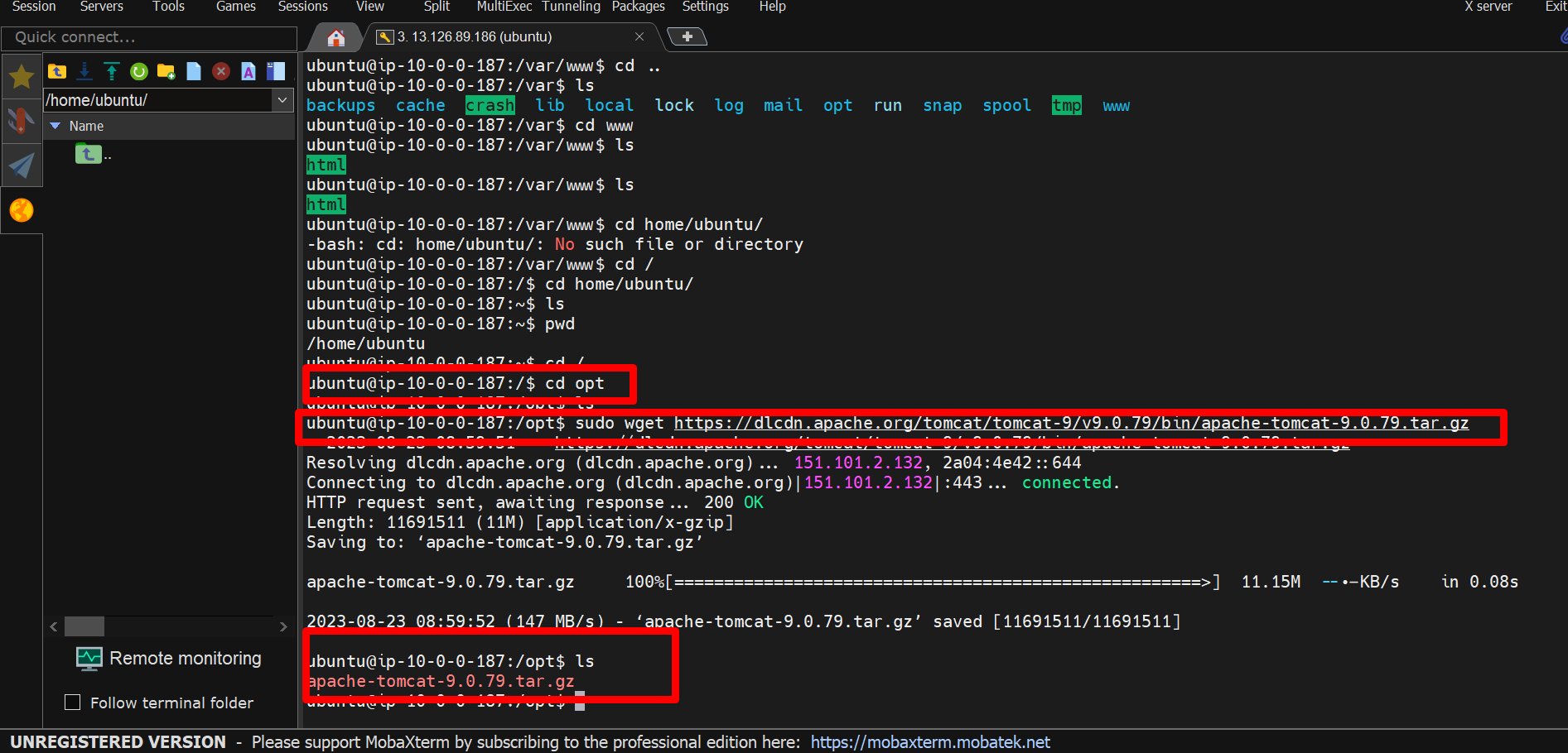

We download apache tomcat in this server, but this is a compressive file we should to extract this file using this command.

Command:- sudo tar -xzvf apache-tomcat-*.tar.gz -C /opt



Now if we want to change this apache-tomcat -9.0.79 name

Command :- sudo mv apache-tomcat-9.0.79 tomcat-9.0

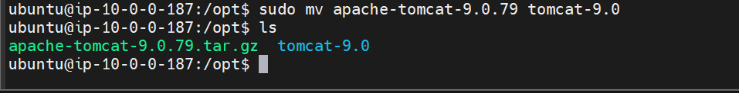

Now we want to browse tomcat server in web browser using **ip** address.

Go to tomcat-9.0 and enter ls for showing list in **tomcat** in that tomcat go to **conf**.

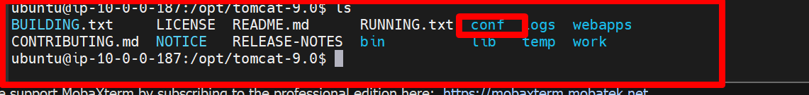

First time enter **cd conf** it shows an error because we must give permissions for that, to give permissions using “**sudo chmod 777 conf**” then again enter **cd conf** after that enter **ls**

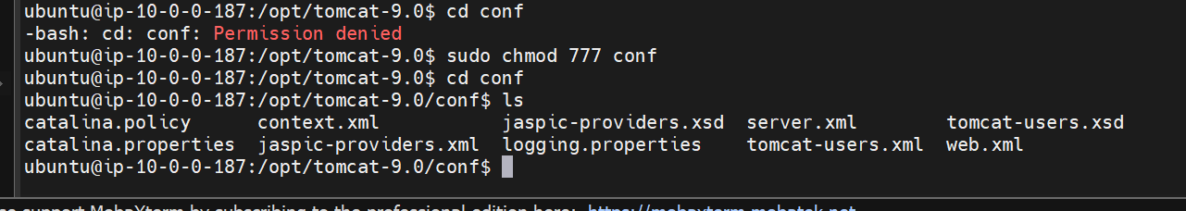

In that **conf** file open **server.xml** andedit that file

Using sudo vim server.xml. Here port default is **8080** but we want to change this port want we want

Now we want tomcat port is **9090** so we enter **9090** port in this file.

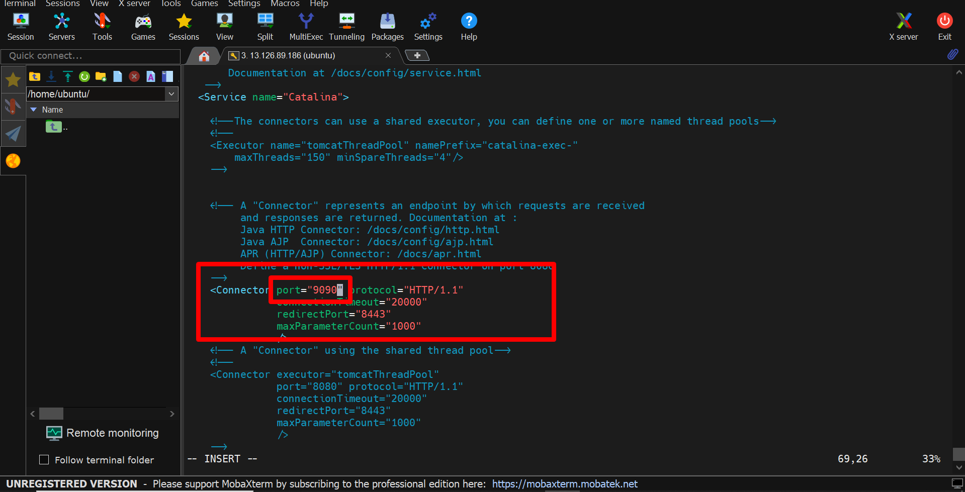

Now we want to browse tomcat in websites

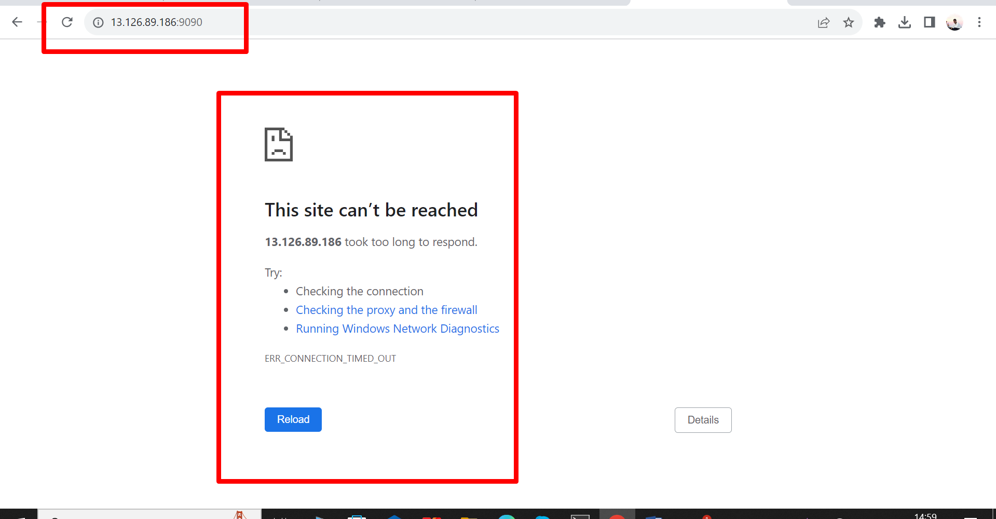

But it doesn’t started because we do not add this port in **security group** so then we want to add this **9090** port in **security group**.

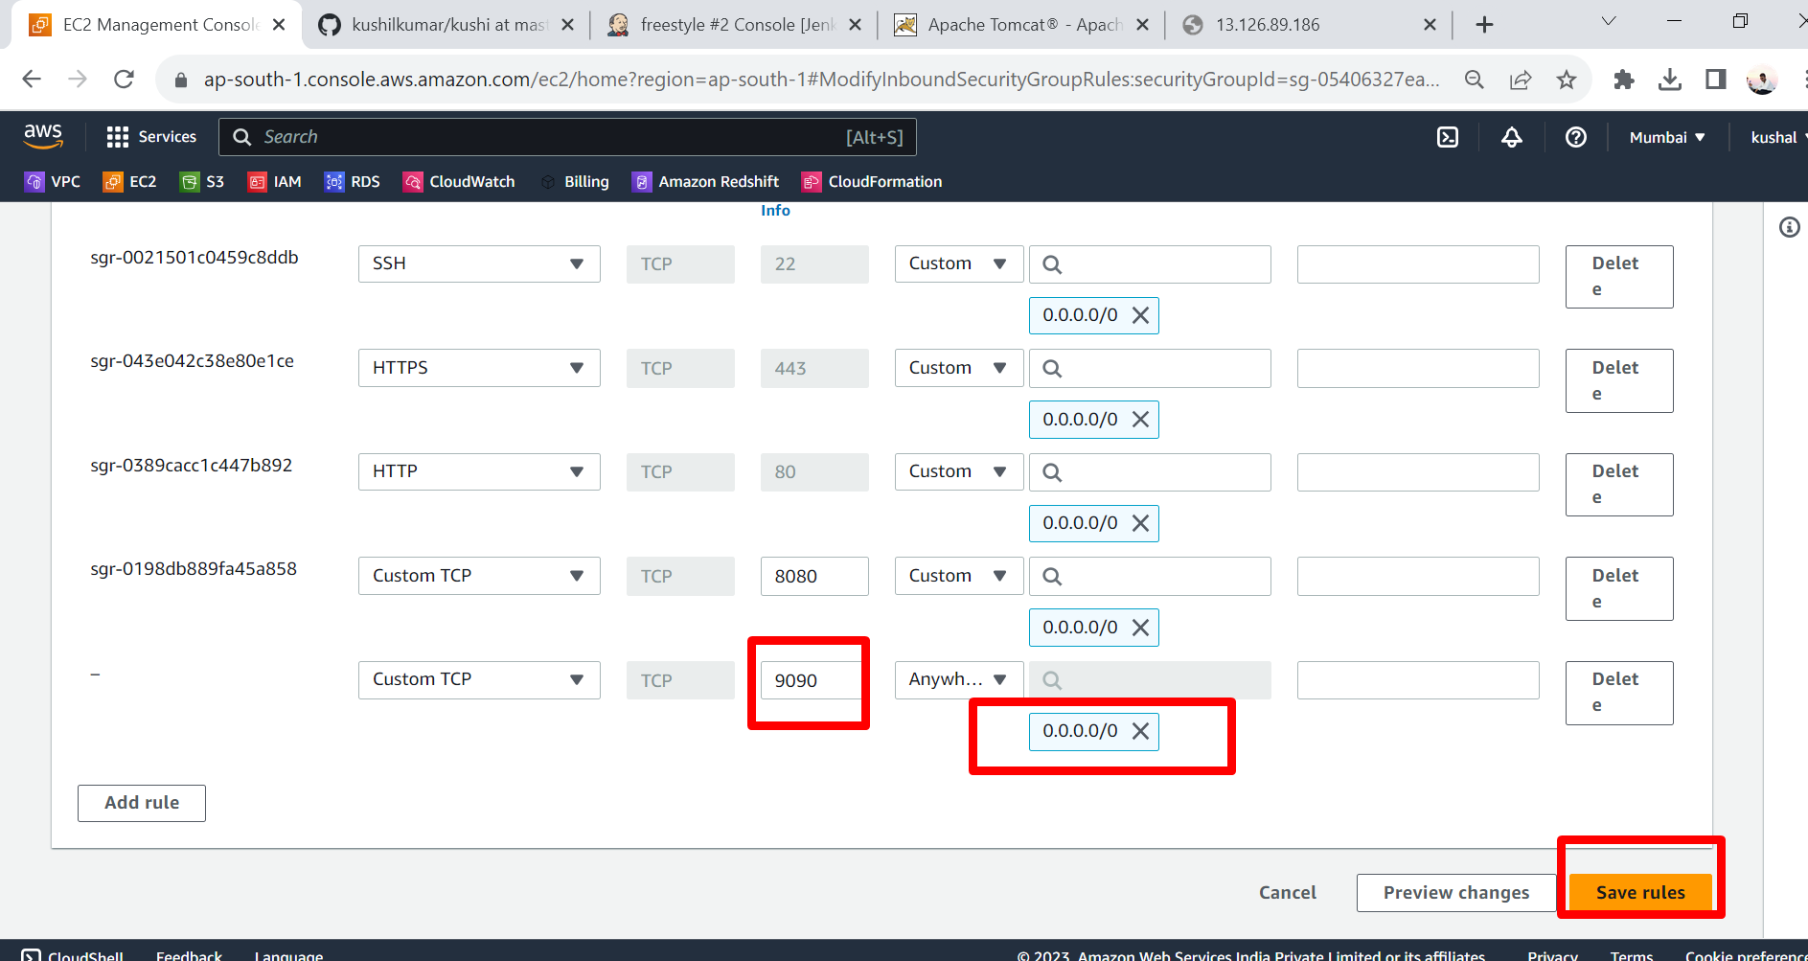

After that we go to server and go to opt -go to tomcat-9.0 -go to bin

Using: - $ **cd opt/tomcat-9.0/bin/**

In that bin path first we want to shutdown and startup

Command: - $ **sudo ./shutdown.sh**

- $ **sudo ./startup.sh**

Now we refresh the page in web browser.

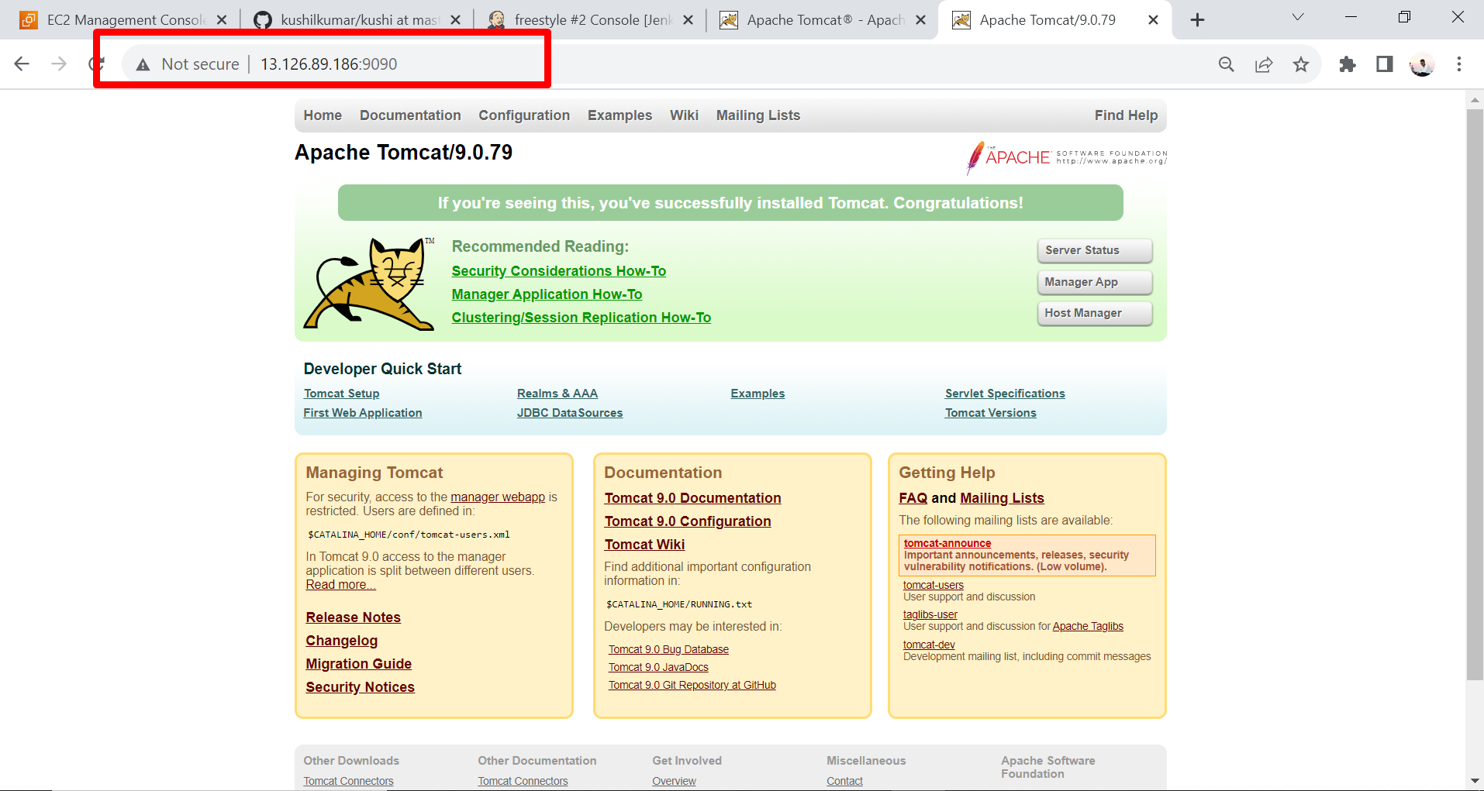

We successfully installed tomcat in server now we want to deploy the file from GitHub to tomcat with jenkins pipeline script.

This is our GitHub repository. Now we want to deploy the aws.txt file into tomcat.

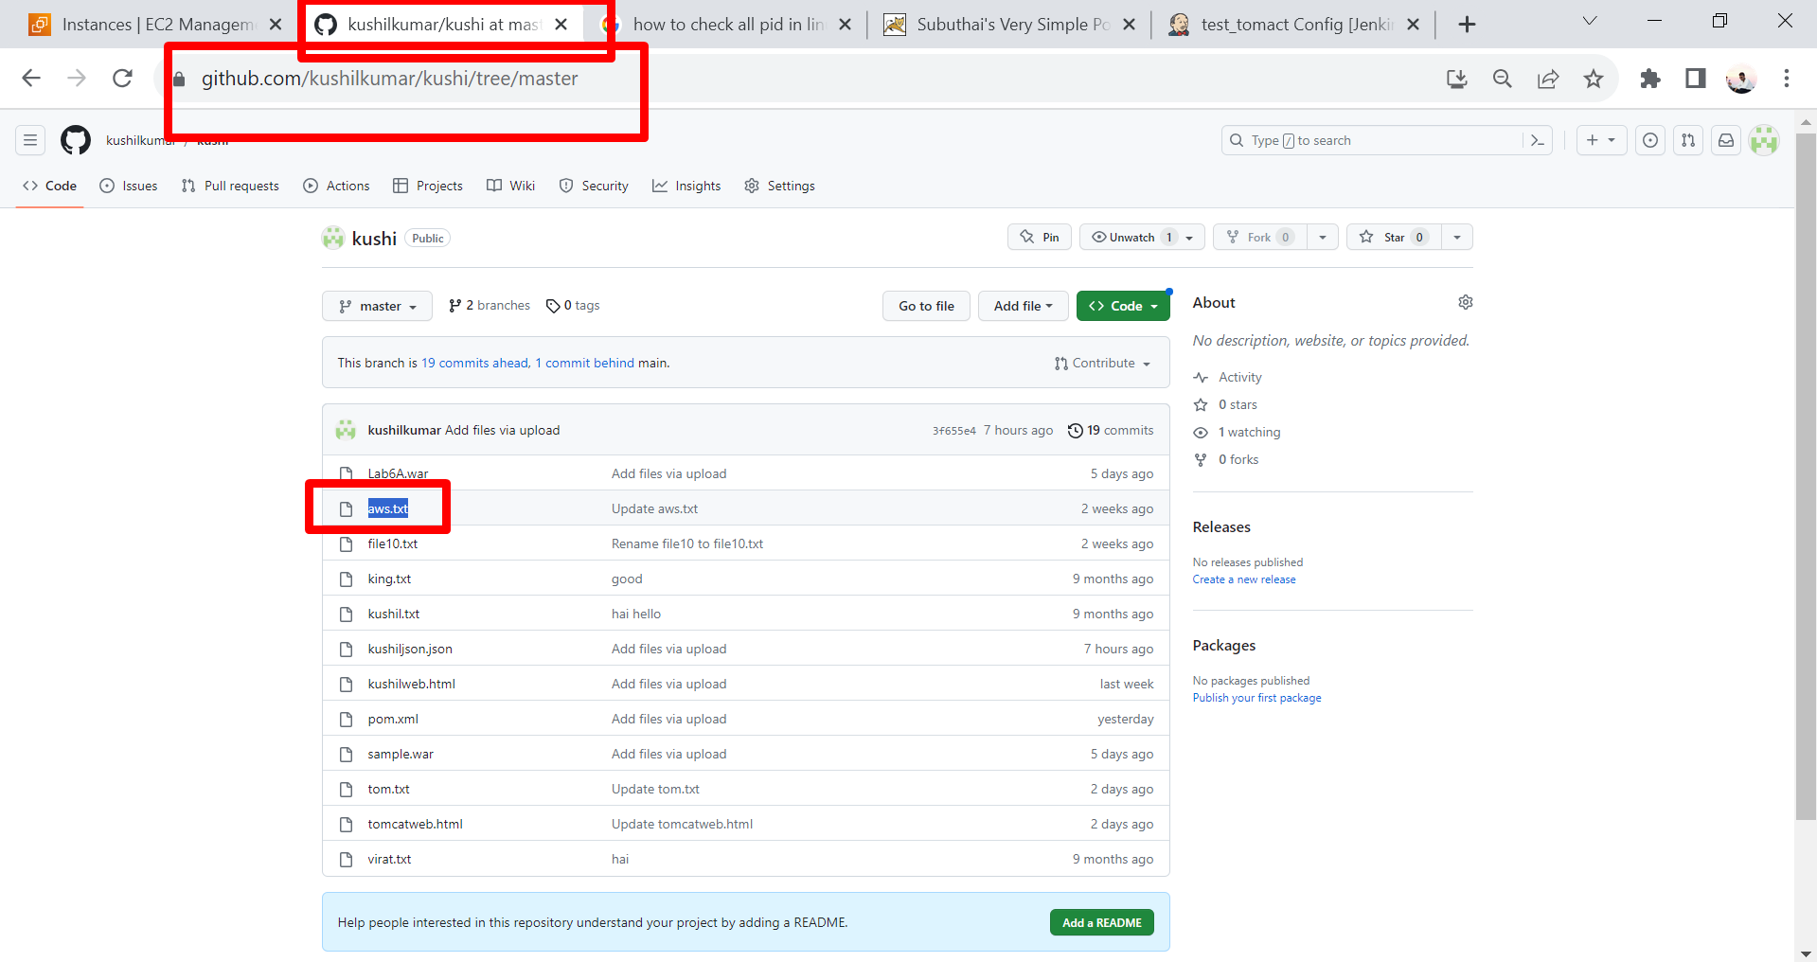

Now we go to jenkins with public IP and port 8080.

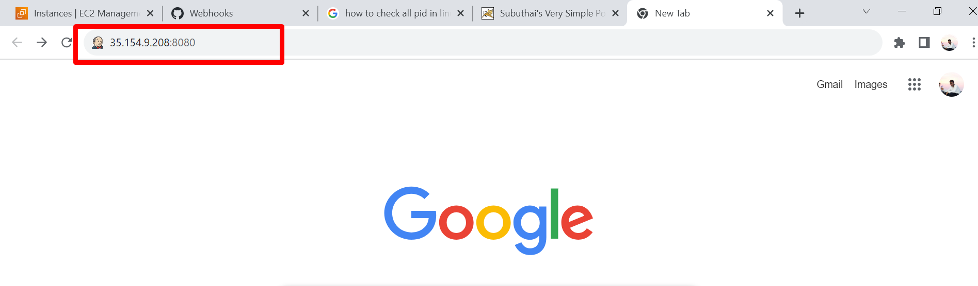

After that give credentials to jenkins and next create a new project with some required name.

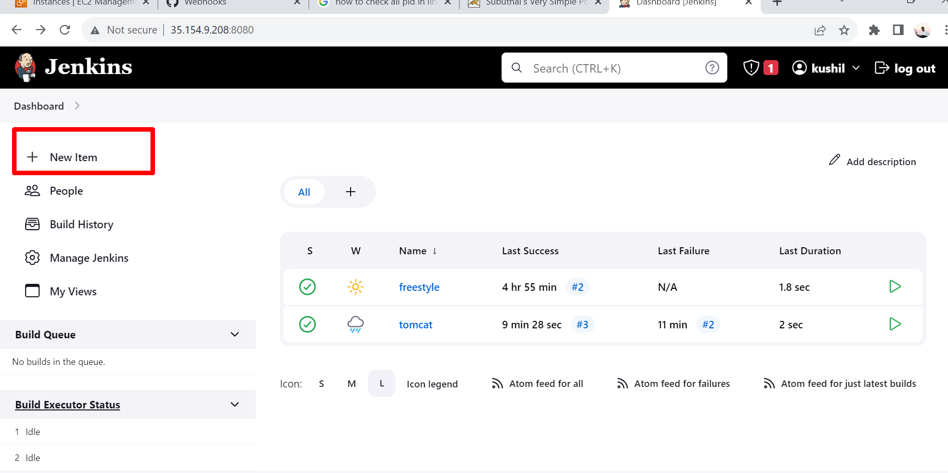

We are taking “test_tomact “ for our project name – next click on pipeline –next click on OK.

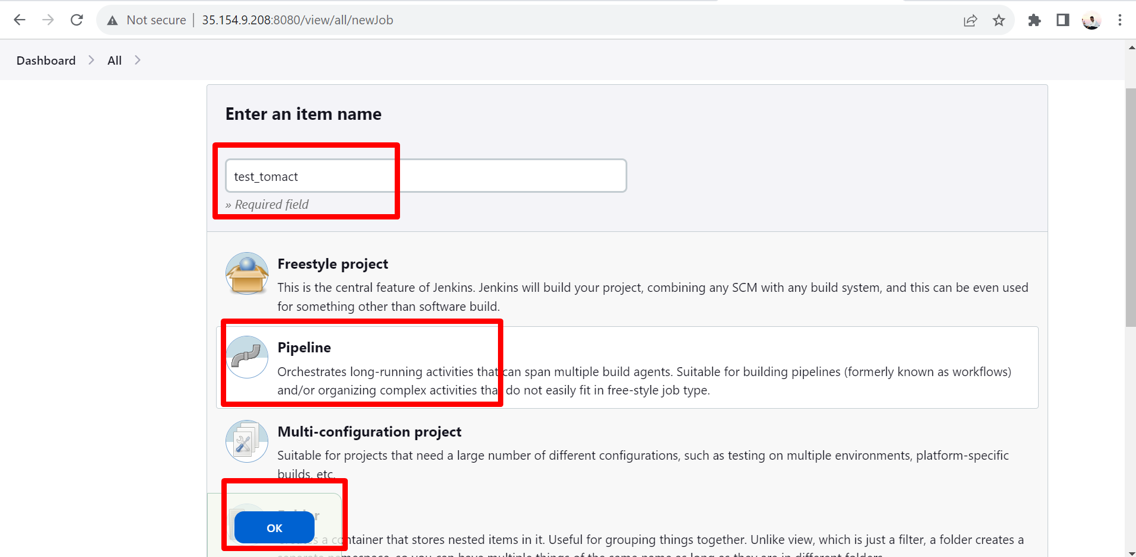

Here go to pipeline in that pipeline select pipeline script .

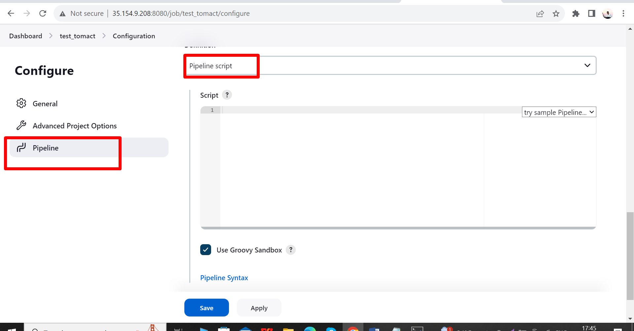

Now add the code in that script.

Code:-

pipeline {

agent any

stages {

stage('Clone and Deploy') {

steps {

checkout([$class: 'GitSCM', branches: [[name: '*/master']], userRemoteConfigs: [[url: 'https://github.com/kushilkumar/kushi.git']]])

// Copy the file to Tomcat webapps directory

sh "cp aws.txt /opt/apache-tomcat-9.0.79/webapps/ROOT/"

}

}

}

}

All are set now click on apply then save.

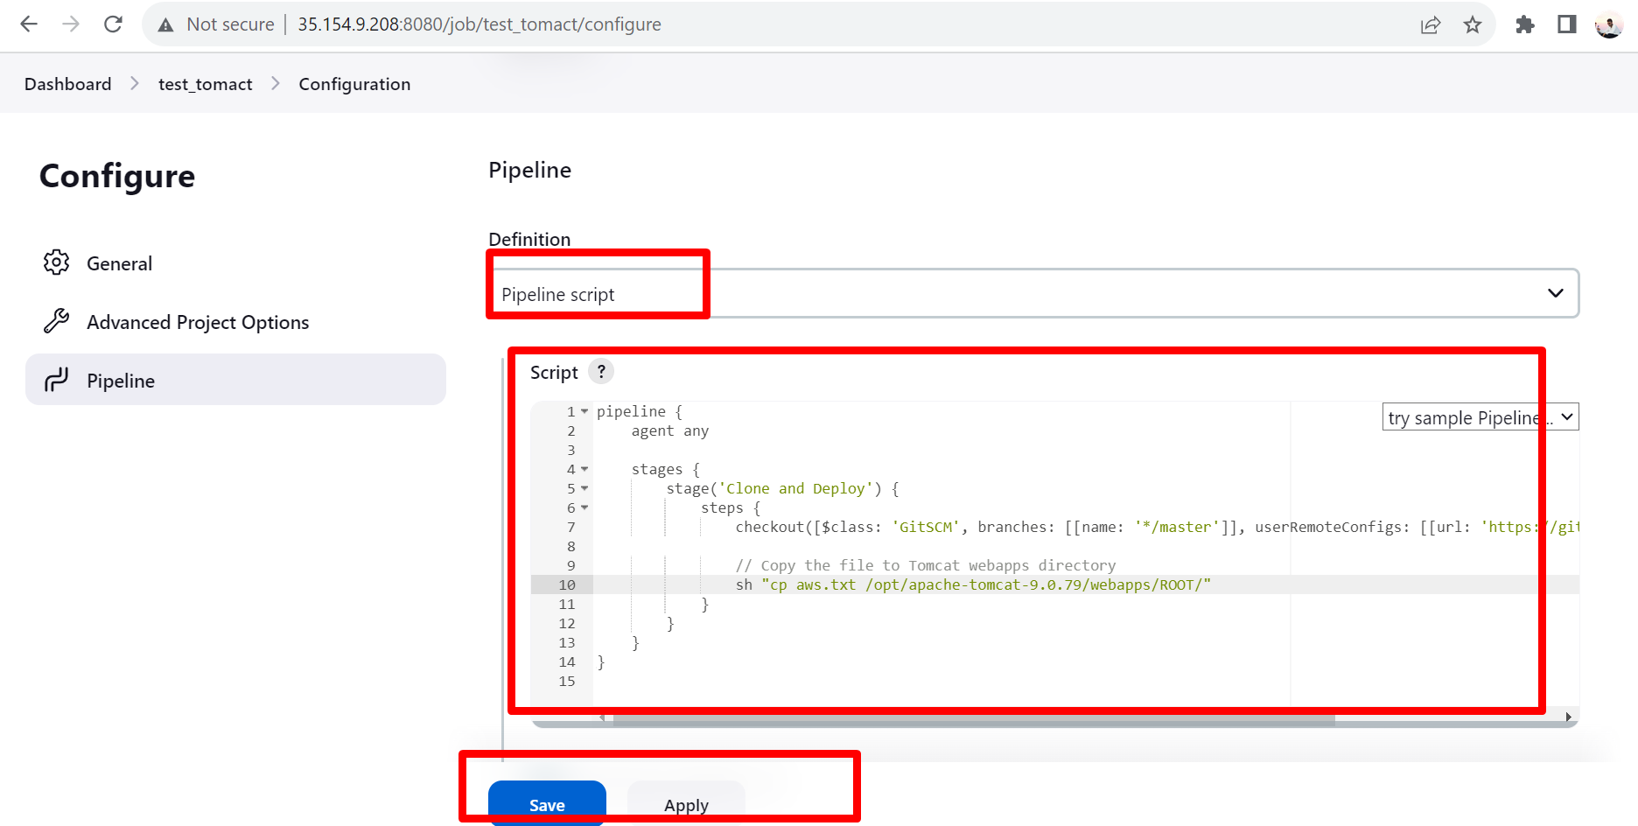

Before we build this code once we check the aws.txt in present or not present in tomcat path .

Here aws.txt is not present.



Now click on build now.

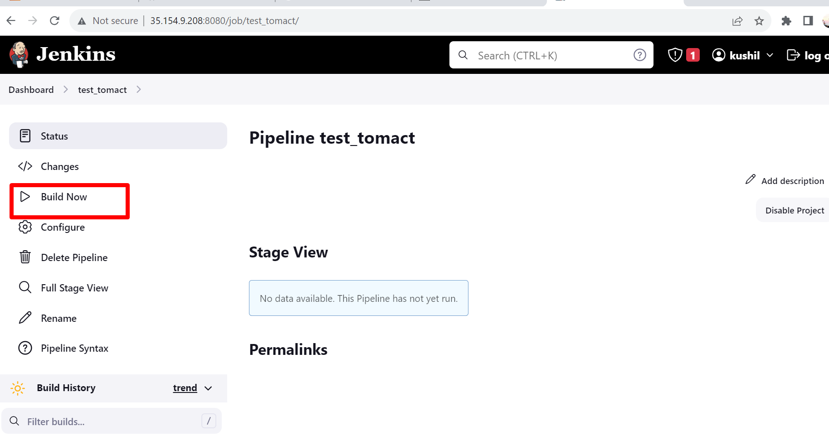

Now we successfully deploy file from GitHub to tomcat.

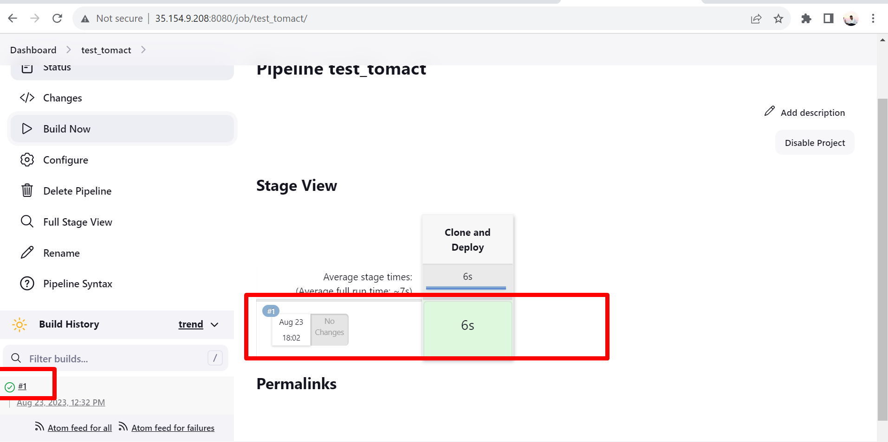

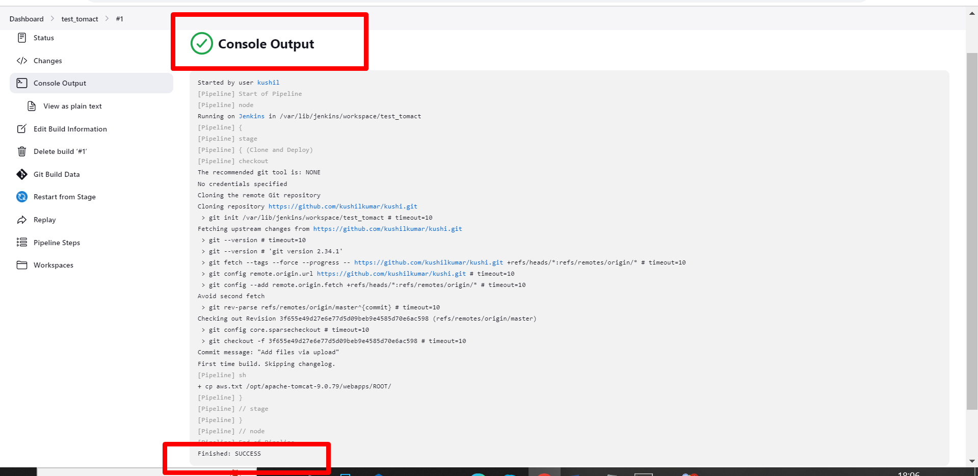

Now we check the aws.txt in tomcat.



Now we check that file in web browser.

url be like :- server IP /tomcatport/file name

in our scenario url = http://35.154.9.208:9090/aws.txt

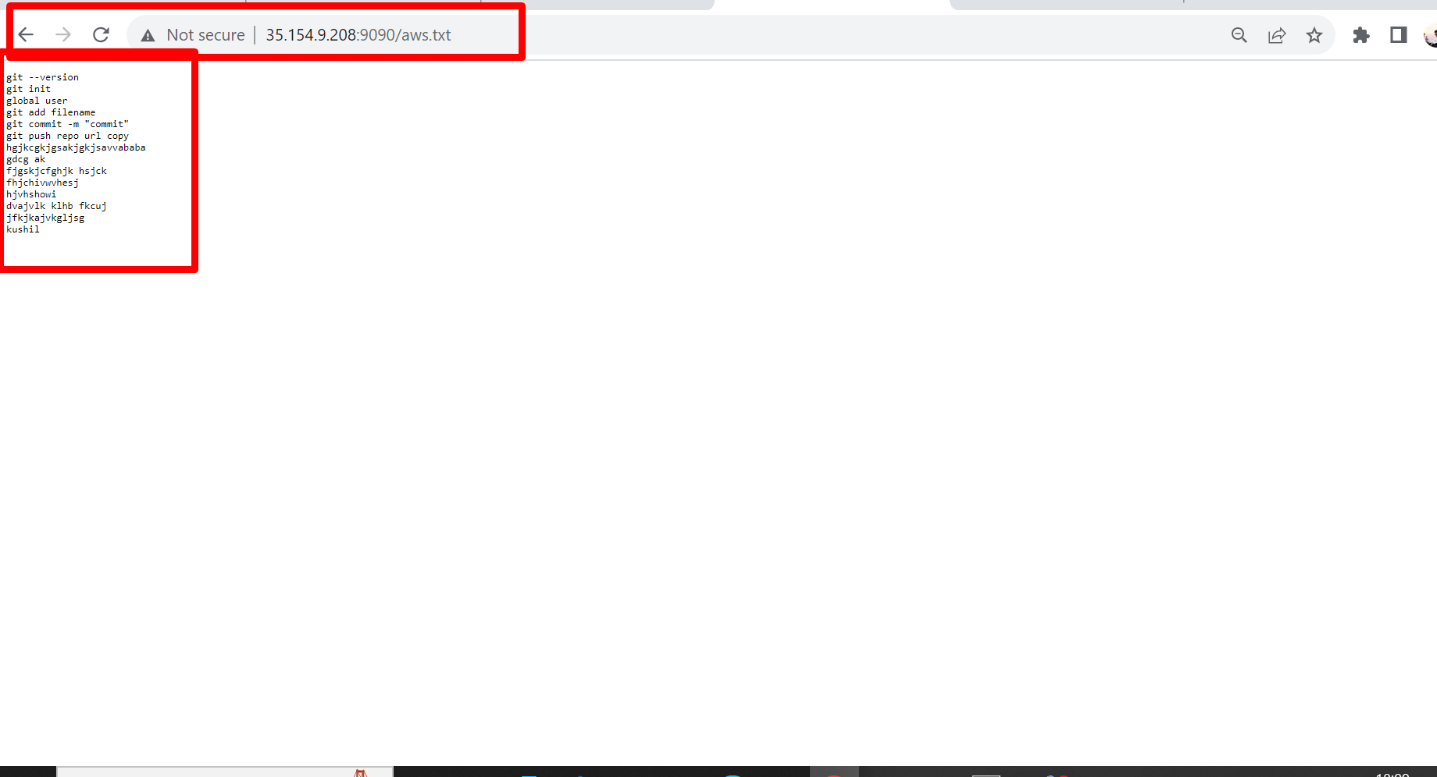

**We successfully install tomcat and deploy files from GitHub to tomcat with Jenkins pipeline script.**

**THANK YOU**